**Power BI Assignment 4**

1. Make a simple dashboard and show columns, bar charts, line charts, and area charts.

Ans-

Columns and Bar Charts :

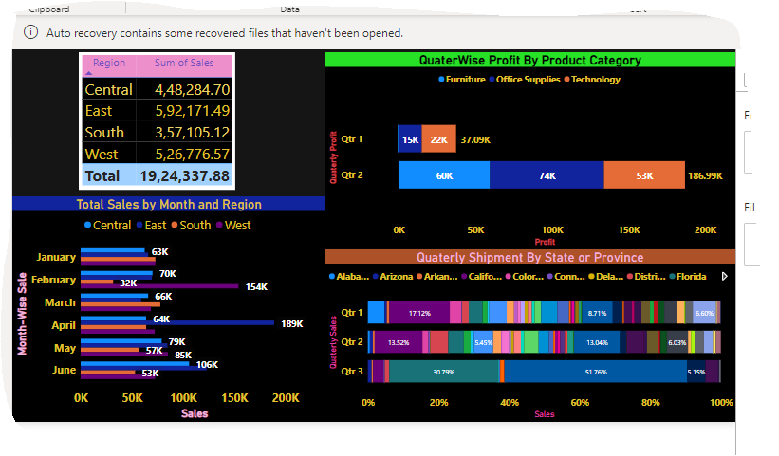

Line Charts :

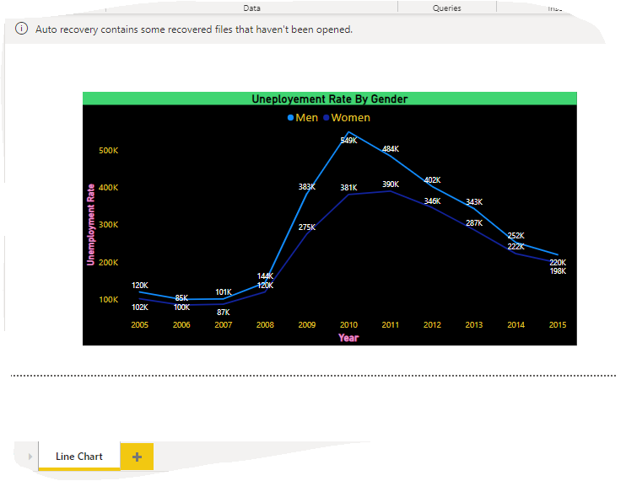

Area Charts:

Stacked Area Chart

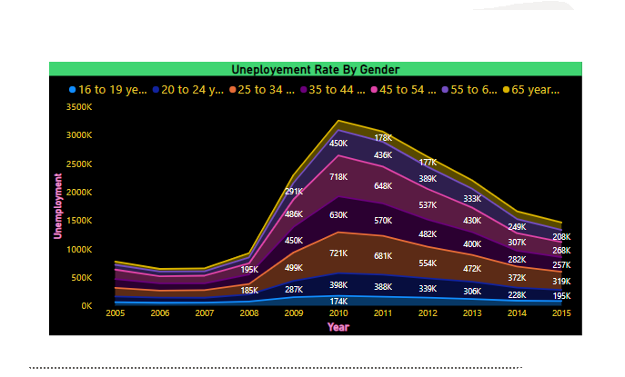

Normal Area Chart:

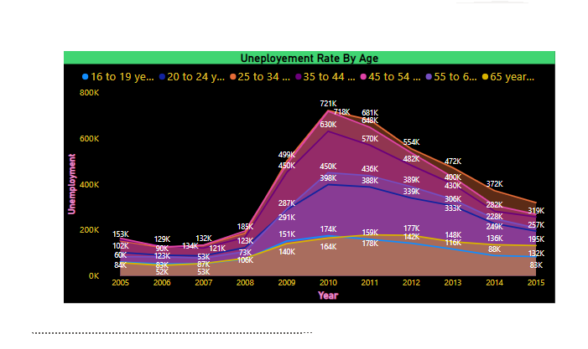

Line and Stacked Column Chart:

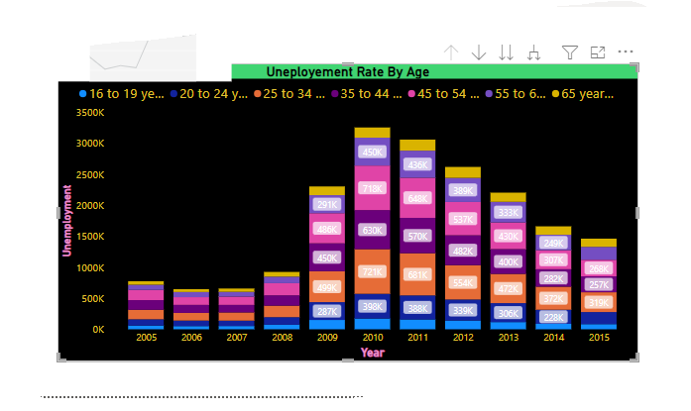

Line and Clustered Column Chart:

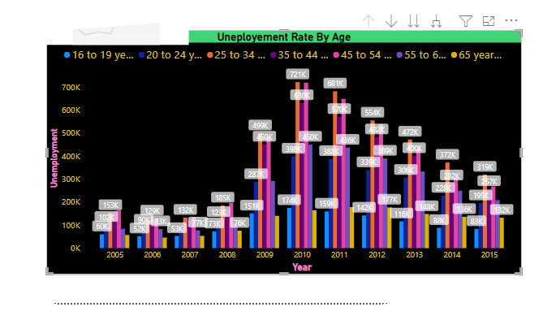

1. Make a simple dashboard and show combination chart, Scatter chart, Shape chart, and Treemap chart.

* Treemap:
* 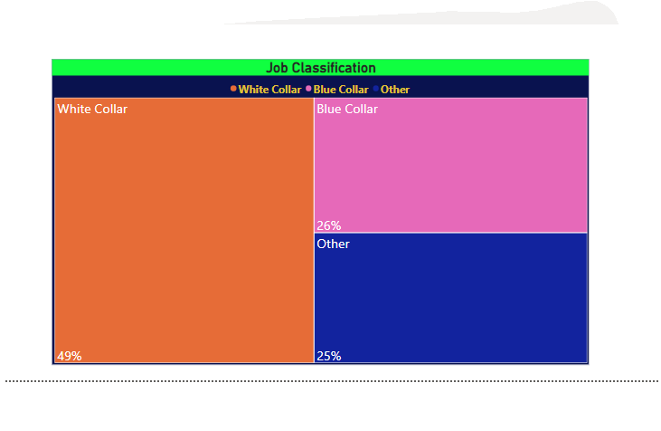

Scatter Chart:

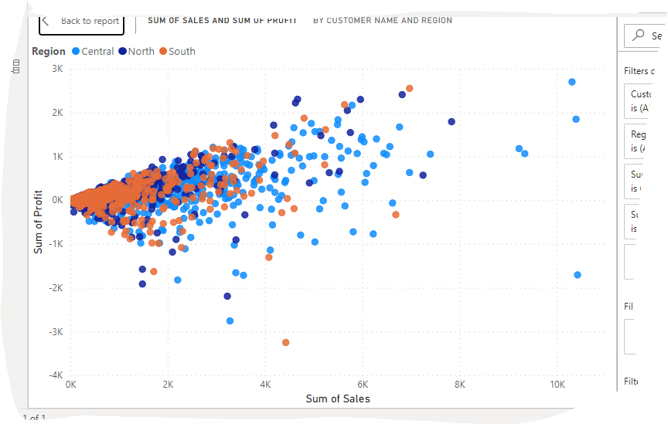

1. Make a dashboard and show 2 maps visualization i.e. basic map and filler maps.
2. Create a report which has:

Bar chart

Card visualizations

Combo chart visualizations

Matrix visualizations

Column chart visualizations

guide: Sales data can be used

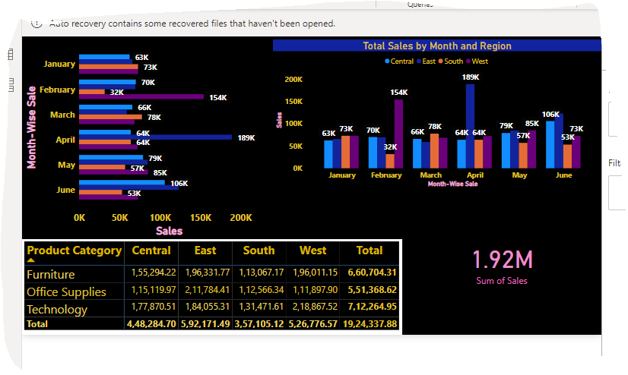

1. Make a report to analyze product sales using treemap visualization.

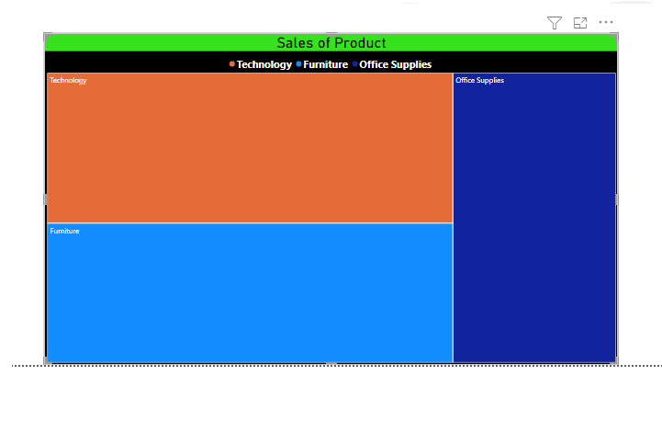

1. Make a dashboard on sales data (Minimum 4 tiles).

